## FPT ACADEMY INTERNATIONAL

**FPT – APTECH COMPUTER EDUCATION**

### Centre Name :….

**Address: 590 Cach Mang Thang 8, District 3, Ho Chi Minh City, Viet Nam.**

**ASKME**

|  |  |  |
| --- | --- | --- |
| **Supervisor:** | Le Mong Thuy | |
| **Semester:** | 1 | |
| **Batch No:** | T1.1907.M0 | |
| **Group No:** | 7 | |
| **Order:** | **Full name** | **Roll No.** |
| 1. | Pham Phu Tra | Student 1218313 |
| 2. | Dam Hoang Anh | Student 1215628 |
| 3. | Nguyen Van Binh | Student 1215621 |
| 4. |  |  |
| 5. |  |  |

Month 10 Year 2019

This is to certify that



Mr. **Pham Phu Tra**

Mr. **Dam Hoang Anh**

Mr. **Nguyen Van Binh**

Has successfully Designed & Developed

**eProject: ASKME**

Submitted by:

**Pham Phu Tra**

Date of Issue:

**11 – 10 – 2019**

Authorized Signature:

# Contents at a Glance

CASE STUDY: ASKME LTD 5

ACKNOWLEDGEMENT 6

Synopsis 6

PROBLEM DEFINITION 7

CUSTOMER REQUIREMENT SPECIFICATION (CRS) 8

Client: ASKME Ltd. 8

Inputs to the system 8

Output from the system 8

Process involved in the application 8

Expected delivery dates 8

11 –10 – 2019 8

List of deliverables 8

Hardware Requirements: 8

Software Requirements 8

Scope of the Work (in brief) 9

ARCHITECTURE AND DESIGN OF THE PROJECT 10

TASK SHEET REVIEW 1 11

SITE MAP 12

MOCK OF THE WEBSITE 13

TASK SHEET REVIEW 2 17

CHECKLIST OF VALIDATIONS 18

WEBSITE DESCRIPTION 19

HOMEPAGE 19

Screenshot 19

PRODUCT 21

Screenshot 21

BRAND PAGE, DETAIL PAGE 25

Screenshot 25

COMPARE 29

Screenshot 29

ABOUT PAGE 29

CONTACT PAGE 30

Screenshot 30

SOURCE CODE INFORMATION 31

Refer 31

Coding 31

Plugin: 31

TASK SHEET REVIEW 3 32

# CASE STUDY: ASKME LTD.

ASKME Ltd. Is a Multi-National Company providing Information services to General People they have been providing information to people through Telephone calls which could include anything from Pin to Piano. Their major source of income comes from informing the customers about those products first for which ASKME is getting paid for.

The BOD’s in their annual general meeting discussed the above problems and the wastage of time and resources on answering such kind of queries online. The BOD’s discussed this at length and has come out with a solution.

They have proposed that they should launch a website by the name CELLINFO.com where the user will get all the information about the various cell phones available in the market of any brand on a click of a Button.

# ACKNOWLEDGEMENT

I would like to acknowledge all those who have given moral support and helped in making the project a success.

I wish to express my gratitude to the eProjects Team all the Head Office, who guided and helped me. I would also like to express my gratitude to all the staff members of my center for not only providing me with the opportunity to work with them on this project but also for their support and encouragement throughout the process.

I also express my sincere gratitude to the eProject Team at the Aptech Head Office and my project guide at the organization, for her valuable guidance and support for the completion of this project.

And finally, I would like to offer many thanks to all my colleagues for their valuable suggestions and constructive feedback.

### Synopsis

ASKME Ltd. Is a Multi-National Company providing Information services to General People they have been providing information to people through Telephone calls which could include anything from Pin to Piano. Their major source of income comes from informing the customers about those products first for which ASKME is getting paid for.

They have the problems from customers are related to information regarding Cell phones which could be one or all the following:

1. What is the Cell Phone Model Number with XYZ features?
2. What are the Features in XYZ cell?
3. What is the current price of the XYZ cell phone?
4. How is XYZ cell phone Different from ABC phone?
5. What is the approximate price of XYZ phone? And many more…

**Hint:** The Web application can be similar to [www.cellinfo.com](http://www.cellinfo.com/) where the users will get all the information about the various cell phones available in the market of any brand on a click of a Button.

# PROBLEM DEFINITION:

After reading the project specifications, the developer states the scope of the project very briefly. This is referred to as the problem definition. Queries of various staff members can be one or all the following:

1. How many pages can be created on the website?
2. What information shoule be displayed about each brand the various cell phones available in the market?

After analyzing the Queries coming from various Customers, they have decided to create the website using HTML5, JavaScript and Geolocation, AngularJS, CSS3, Bootstrap 3.3 libraries from getboostrap.com, jQuery plugins, and Visual Studio Code or others HTML editor. Also, the site will be tested on popular browsers.

# CUSTOMER REQUIREMENT SPECIFICATION (CRS)

### Client: ASKME Ltd.

Business/Project Objective: Provide information services to General People they have been providing information to people through Telephone calls which could include anything from Pin to Piano.

### Inputs to the system:

* Create a website with home pages, menu page for each various cell phones.
* Contact page has an address and send email button and display company map location.

### Output from the system:

* Display all information about phones, brand, phone feature, …
* Display information about address with map location.

### Process involved in the application:

* Download Word documents about detail feature cell phone.
* Compare information between at least 2 phones of different brands.

**Expected delivery dates:**

**11– 10– 2019**

### List of deliverables:

* Document
* User guide
* Source code

### Hardware Requirements:

* Intel Core i3 Processor or higher
* 2GB RAM or higher
* 1920 x 1080 screen resolutions or higher
* 80 GB Hard Disk space

### Software Requirements:

* Windows 7, 10, or higher
* HTML5 and JavaScript supporting browser.
* Bootstrap 3.3 libraries from getbootstrap.com, jQuery plugins, and Visual Studio Code, Notepad ++, Dreamweaver or others HTML editor.

### Scope of the Work (in brief):

After having a thorough discussion among members of the team, decision has been made to point out crucial requirements which need to be developed:

1. A home page for ASKME Ltd. That will further display menu options for Cellphone, Compare and Contact Us
2. Cellphone menu will display the information about brands, new phone.
3. Compare page will display specification between 2 phones with the same brand or difference brand.
4. Contact Us include the address, send email and location.

# ARCHITECTURE AND DESIGN OF THE PROJECT

The application will have a client-server architecture.



CLIENTS



SERVER



**Front End Tec o ogies**

**HTML5, CSS3,**

**JavaScript,**

**Boots p, jQuery plugin, Visual Studio Code, Dreamweaver**



# TASK SHEET REVIEW 1

|  |  |  |  |  |  |  |  |
| --- | --- | --- | --- | --- | --- | --- | --- |
| **Project Ref. No.:**  **eProject / Askme Mobile / 01** | | **Activity Plan Prepare d By:** | **Project Title:** | **Date of Preparation of Activity Plan:** | | | |
| **Sr.**  **No.** | **Task** | **Actual Start Date** | **Actual Days** | **Team Mate**  **Names** | **Status** |
| 1 | Problem  Definition | Dam Hoang Anh | Askme | 7/010/2019 | 1 | Tra | Completed |
| 2 | Customer  Requirement Specification | 8/10/2019 | 1 | Binh | Completed |
| 3 | Architechture  and Design | 9/10/2019 | 1 | Anh | Completed |

|  |  |
| --- | --- |
| **Date:** | |
| Signature of Instructor:  **Le Mong Thuy** | Signature of team leader:  **Dam Hoang Anh** |

# SITE MAP

The sample site map illustrates the navigation flow of the objects on the Web portal.

**Home**

Home

Home page

Brand 1 page

Product

Product page

Brand 2 page

About US

Compare page

Contact Us

Contact page

About us

# MOCK OF THE WEBSITE

Home Slider

Menu bar

Logo

**Home page**

Product introduction and Ad

Register and login

Header

Sellers

Child menu

Footer

Promotions

Product

Business

Our Team

# MOCK OF THE WEBSITE

Banner Page

Menu bar

Logo

**Product page**

Register and login

Header

Seach bar

Product menu

Product

Footer

# MOCK OF THE WEBSITE

Menu bar

Logo

**About us page**

Register and login

Header

Information and news page

Footer

# MOCK OF THE WEBSITE

Menu bar

Logo

**Contact us page**

Register and login

Header

Google Map

Contact Us Feedback

Footer

# TASK SHEET REVIEW 2

|  |  |  |  |  |  |  |  |
| --- | --- | --- | --- | --- | --- | --- | --- |
| **Project Ref. No.:**  **eProject / Askme Mobile / 01** | | **Project Title:** | **Activity Plan Prepared By:** | **Date of Preparation of Activity Plan:** | | | |
| **Sr.**  **No.** | **Task** | **Actual Start Date** | **Actual Days** | **Team Mate**  **Names** | **Status** |
| 1 | Site map | Askme | Dam Hoang Anh | 23/10/2019 | 1 | Tra | Completed |
| 2 | Mock of the  website | 23/10/2019 | 1 | Anh | Completed |

|  |  |
| --- | --- |
| **Date:** | |
| Signature of Instructor:  **Le Mong Thuy** | Signature of team leader:  **Dam Hoang Anh** |

### CHECKLIST OF VALIDATIONS

|  |  |
| --- | --- |
| **Option** | **Validated** |
| Do all numeric variables have a default value of zero? | n/a |
| Does the administrator have all the rights to create and delete the  records? | n/a |
| Are all the records properly fed into the appropriate database? | n/a |
| Have all the modules been properly integrated and are  completely functional? | Yes |
| Have all the Design and Coding Standards been followed and  impletemented? | Yes |
| Is the GUI design consistent all over? | Yes |
| Is the navigation sequence correct through all the forms/screens  in the application? | Yes |
| Is exception handling mechanism implemented in all the  screens? | n/a |
| Are all the program codes working? | Yes |

# WEBSITE DESCRIPTION

### HOMEPAGE

**Screenshot:**

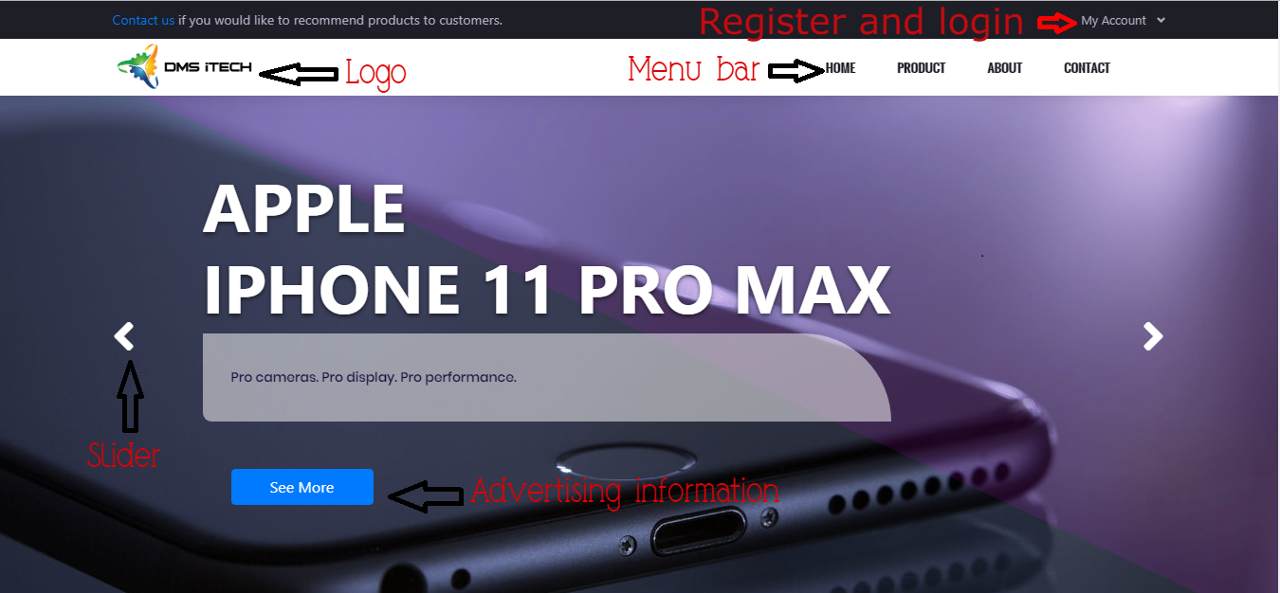

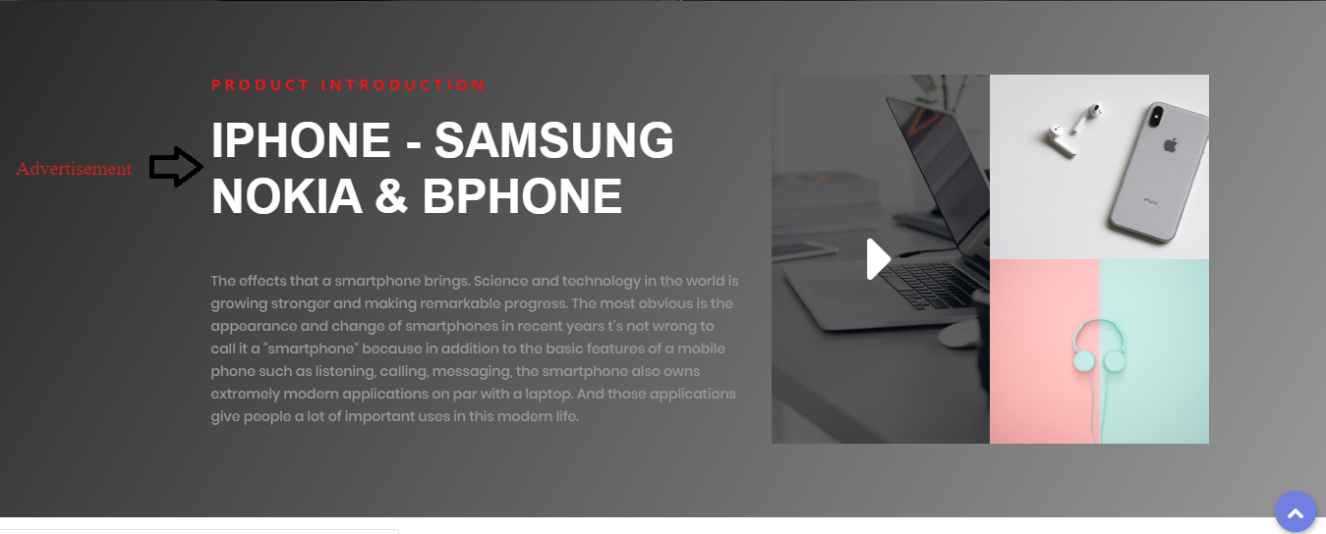

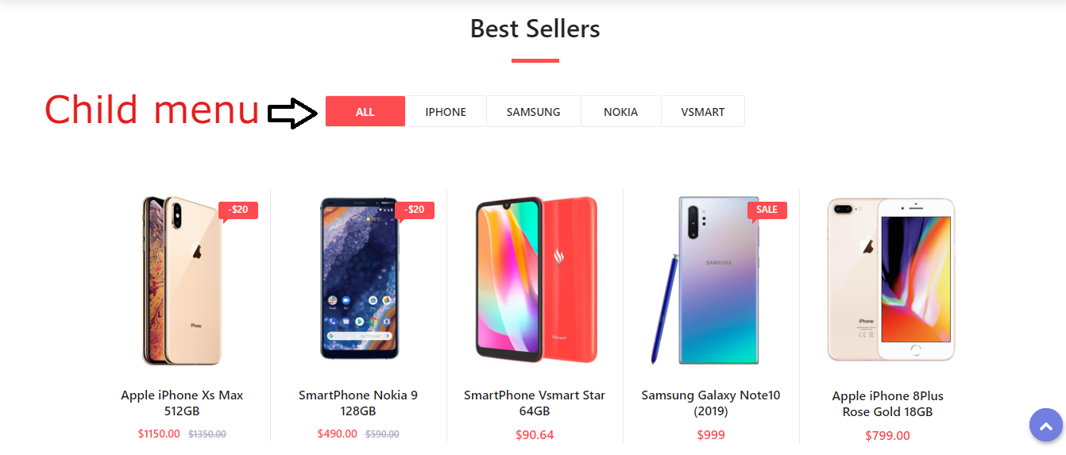

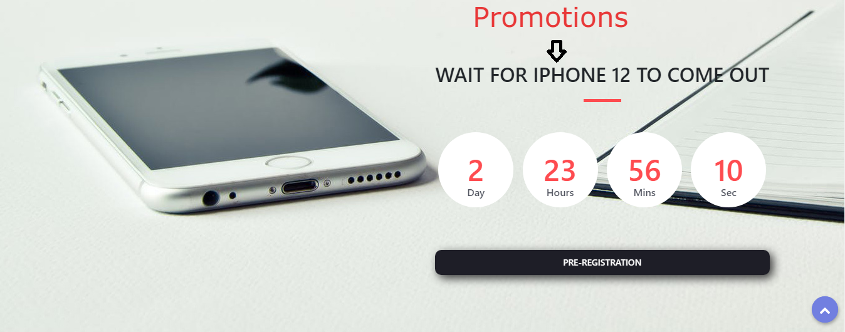

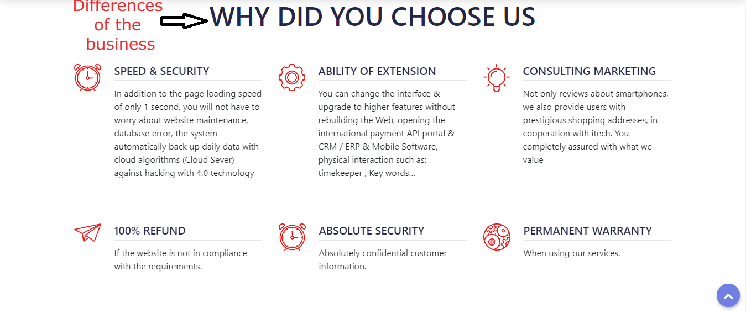

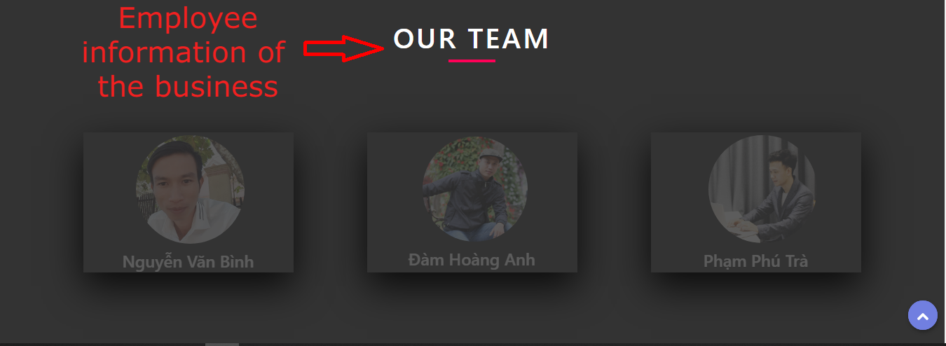

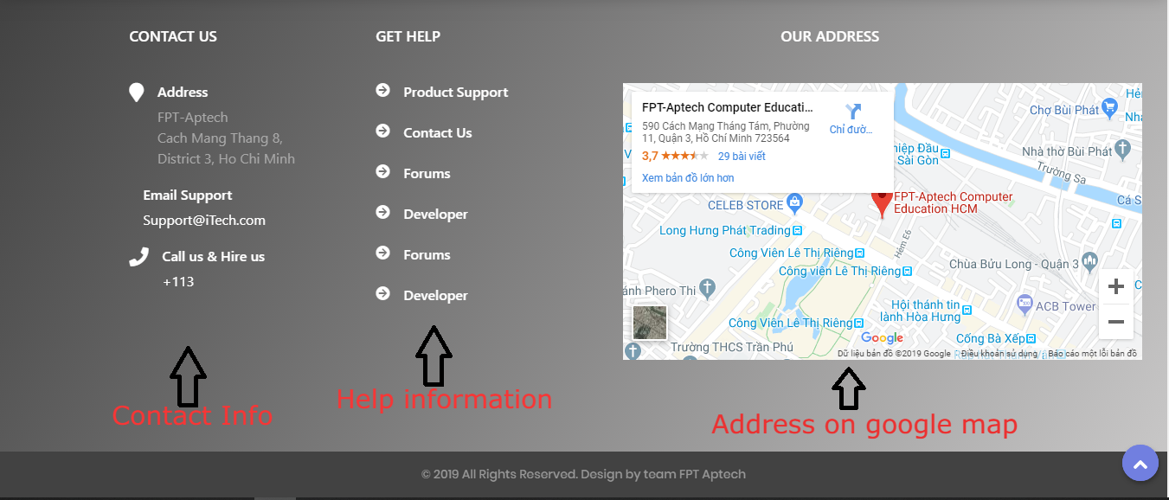

### PRODUCT, SALE PRODUCT, NEW PRODUCT

**Description:**

Product page displays mobile products, sale product page and new products.

**Screenshot**

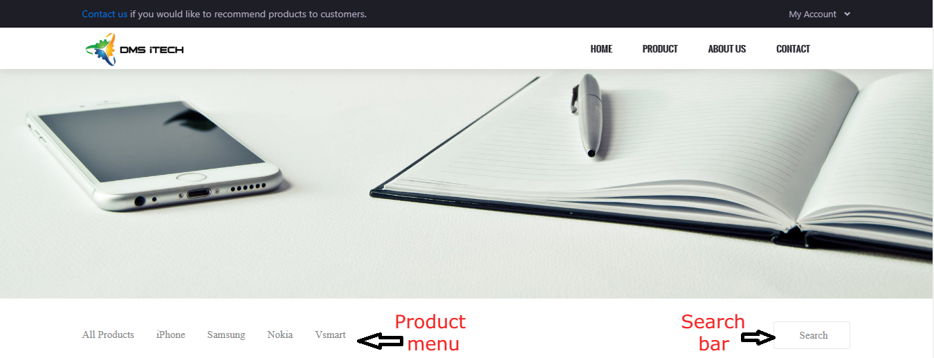

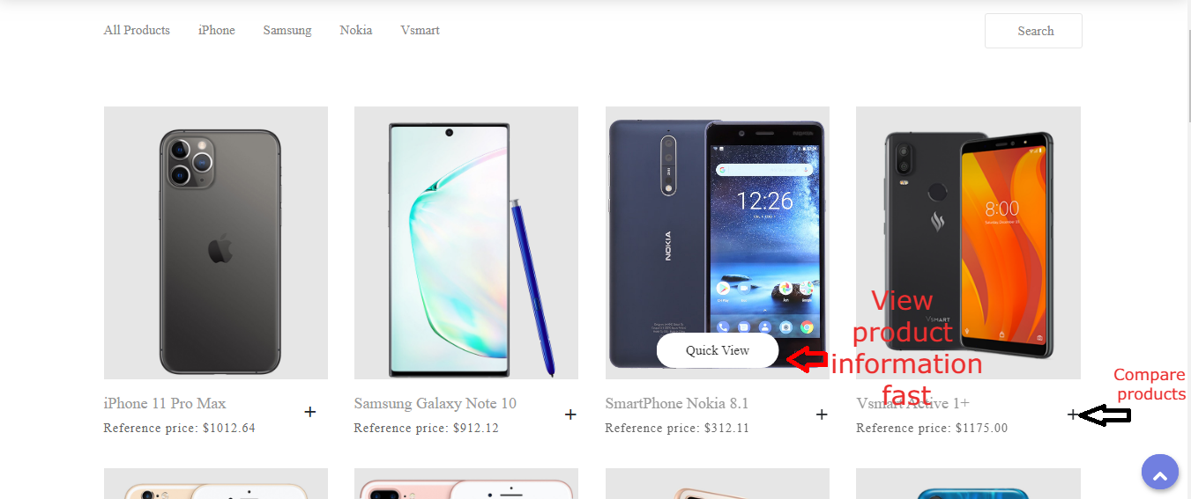



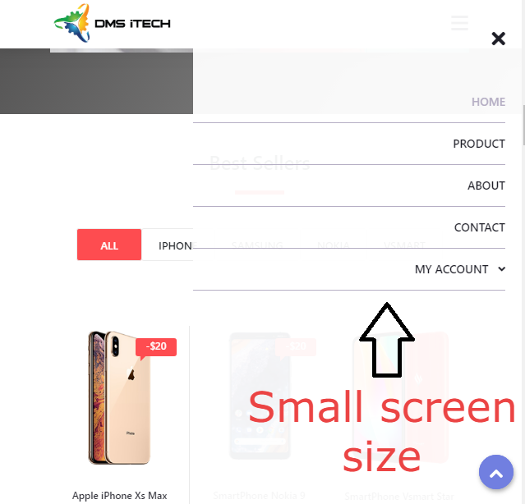

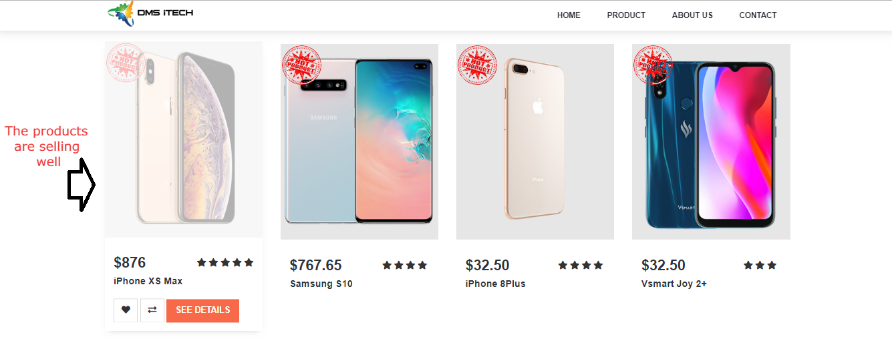

### BRAND PAGE, DETAIL PAGE

**Screenshot**

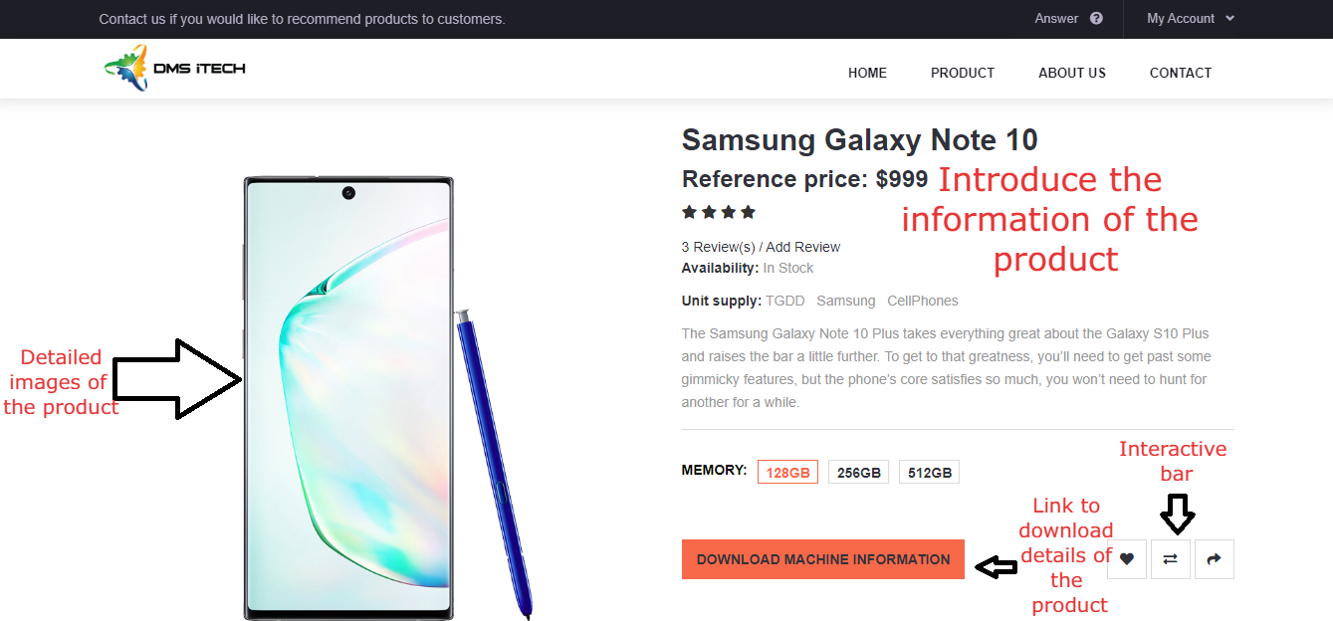

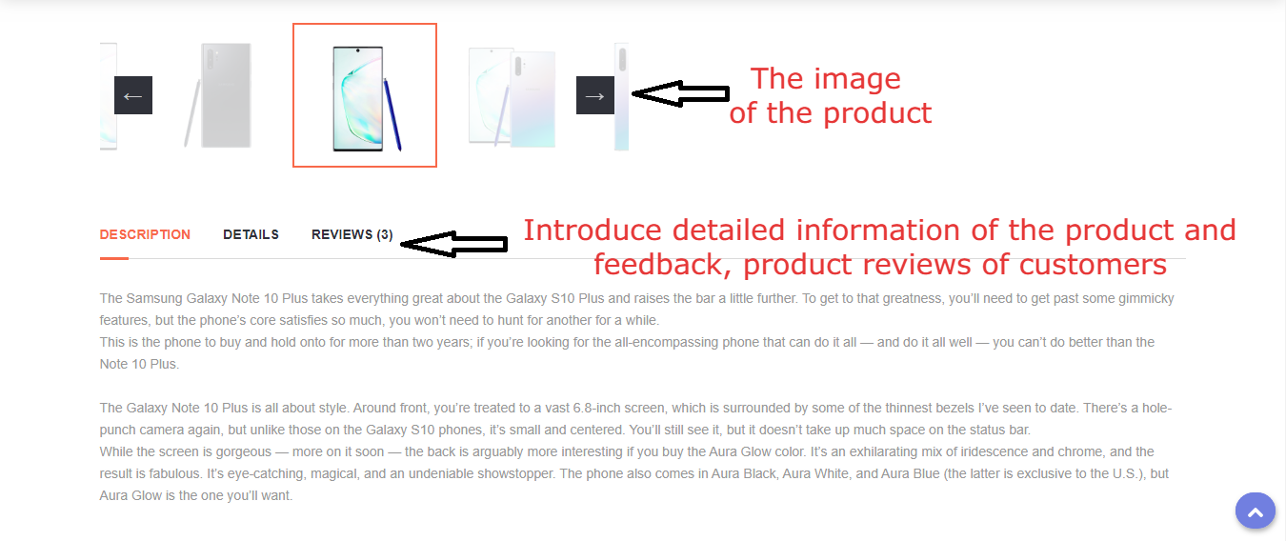

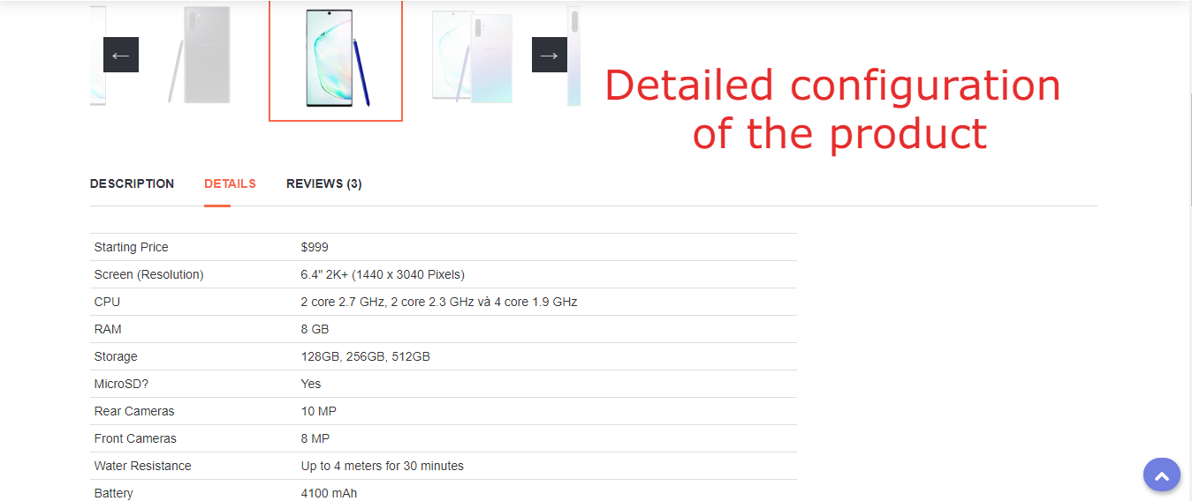

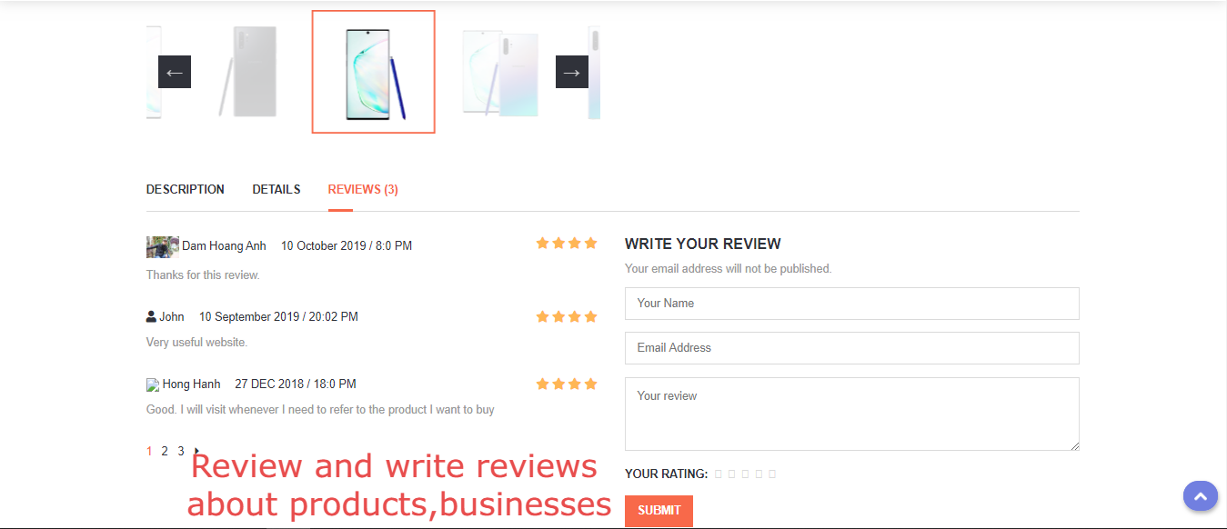

### COMPARE PAGE

**Screenshot**

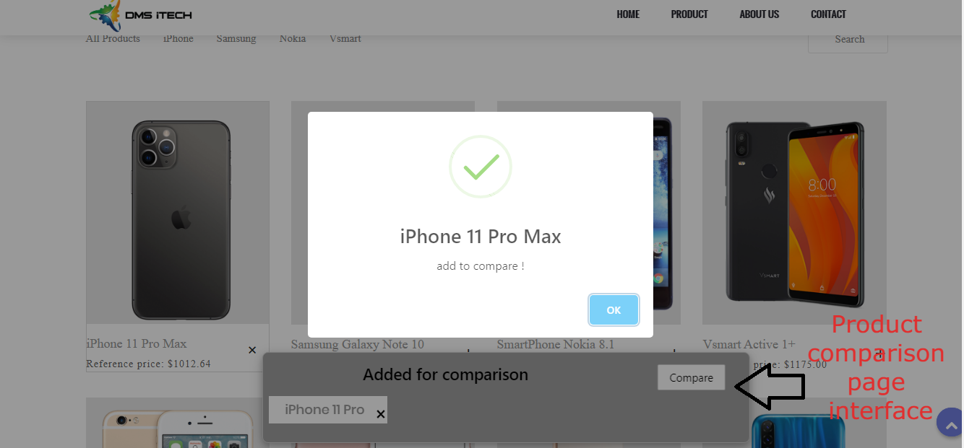

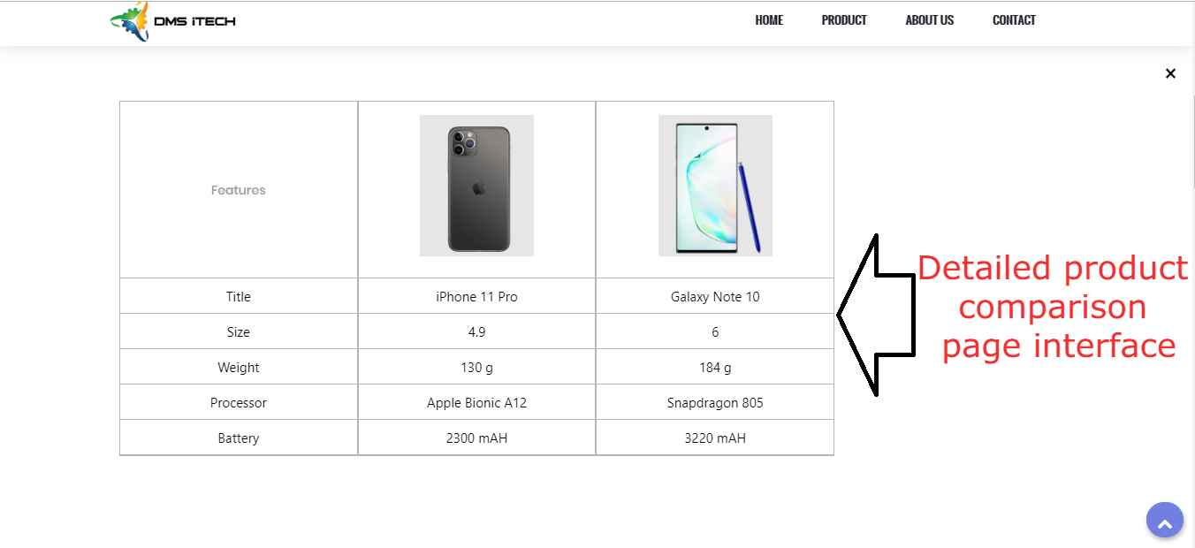

**ABOUT US PAGE**

**Screenshot**

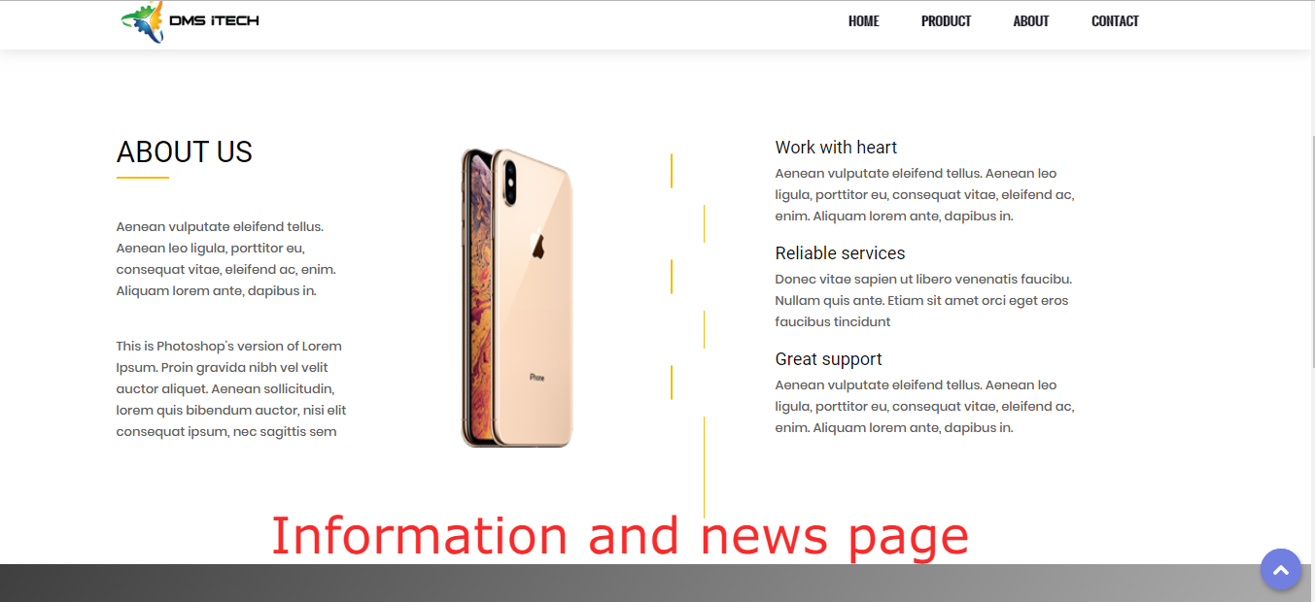

### CONTACT PAGE

**Description:**

This webpage allows users to request information they inquire to Askme and displays the geo location of our company.

**Screenshot**

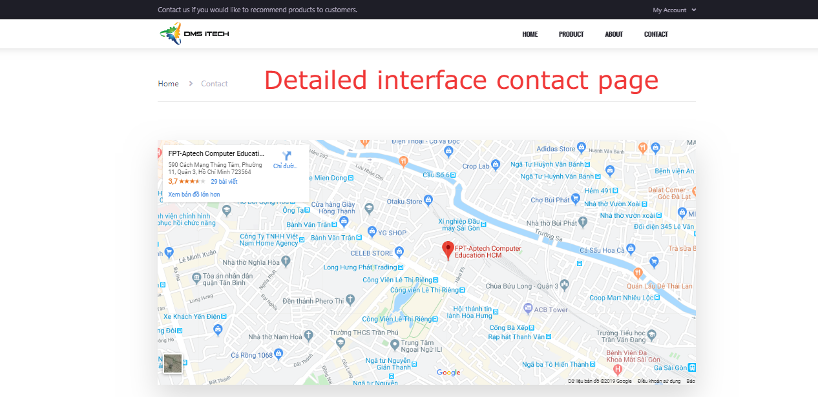

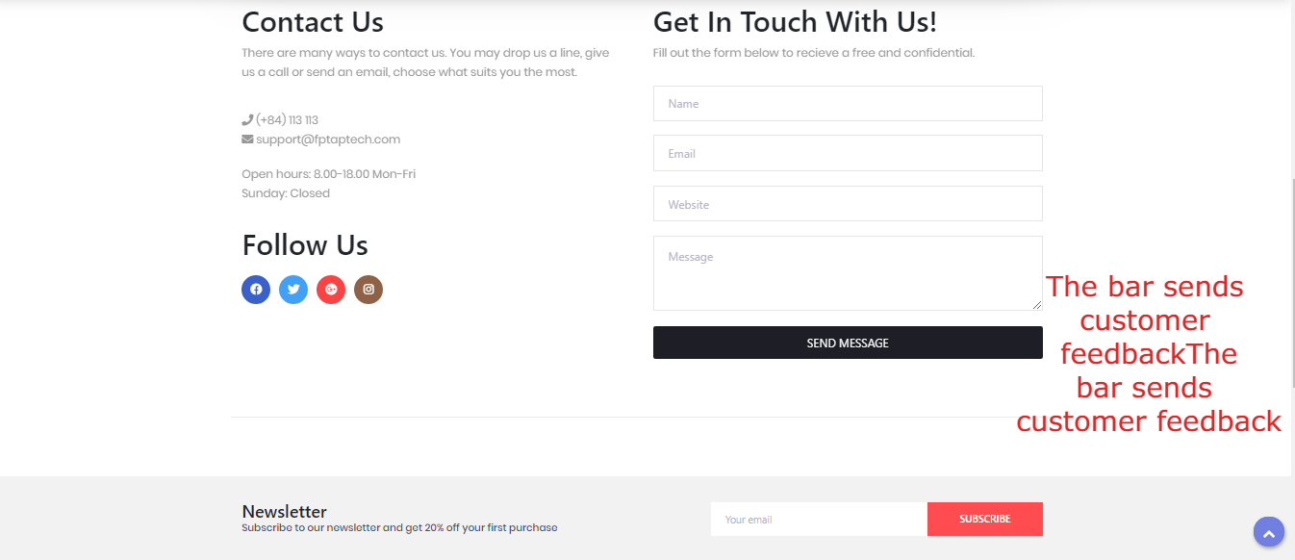

### SOURCE CODE INFORMATION

**Refer:**

[https://www.apple.com](https://www.apple.com/) <https://www.nokia.com/phones/en_int> [https://www.samsung.com/global/galaxy](https://www.samsung.com/global/galaxy/) [https://images.google.com](https://images.google.com/)

https://thegioididong.com

**Coding:**

jQuery-3.2.1 Modernizr 2.8.3

Bootstrap v4.0.0 CSS, JavaScript

**Plugin:**

jQuery Easing v1.3 Font Awesome 4.7.0

GreenSock Animation Platform Isotope v3.0.4

Owl Carousel v2.2.1 Parallax.js v1.5.0 ScrollMagic v2.0.5

**TASK SHEET REVIEW 3**

|  |  |  |  |  |  |  |  |
| --- | --- | --- | --- | --- | --- | --- | --- |
| **Project Ref. No.:**  **eProject / Askme Mobile / 01** | | **Project Title:** | **Activity Plan Prepare d By:** | **Date of Preparation of Activity Plan:** | | | |
| **Sr.**  **No.** | **Task** | **Actual Start Date** | **Actual Days** | **Team Mate**  **Names** | **Status** |
| 1 | Home page | Askme | Dam Hoang Anh | …/10/2019 | 3 | Anh | Completed |
| 2 | Product page | …/10/2019 | 2 | Tra | Completed |
| 3 | New product  page | …/10/2019 | 1 | Binh | Completed |
| 4 | Sale product  page | …/10/2019 | 1 | Anh | Completed |
| 5 | Apple page | …/10/2019 | 5 | Tra | Completed |
| 6 | Samsung page | …/10/2019 | 5 | Binh | Completed |
| 7 | Vsmart page | …/10/2019 | 5 | Anh | Completed |
| 8 | Nokia page | …/10/2019 | 2 | Tra | Completed |
| 9 | Compare | …/10/2019 | 2 | Binh | Completed |
| 10 | About,Contact Us page | …/10/2019 | 1 | Anh | Completed |
| 11 | JS, CSS,  Theme | …/10/2019 | 1 | Tra | Completed |
| 12 | Report |  |  | …/10/2019 | 1 | Binh | Completed |
| 13 | User Guide |  |  | …/10/2019 | 1 | Anh | Completed |
| 14 | Test code |  |  | …/10/2019 | 1 | Tra | Completed |
| 15 | Test final |  |  | …/10/2019 | 1 | Binh | Completed |
| 16 | Test final |  |  | …/10/2019 | 1 | Anh | Completed |

|  |  |
| --- | --- |
| **Date:** | |
| Signature of Instructor:  **Le Mong Thuy** | Signature of team leader:  **Dam Hoang Anh** |